# MY HEALTH JOURNEY

After login, you will see the **My Health Journey** screen containing a timeline of your Problems (i.e.-Diagnoses), Encounters, Reports, Lab Results, Medications, and Procedures contained within your HIE (Health Information Exchange).

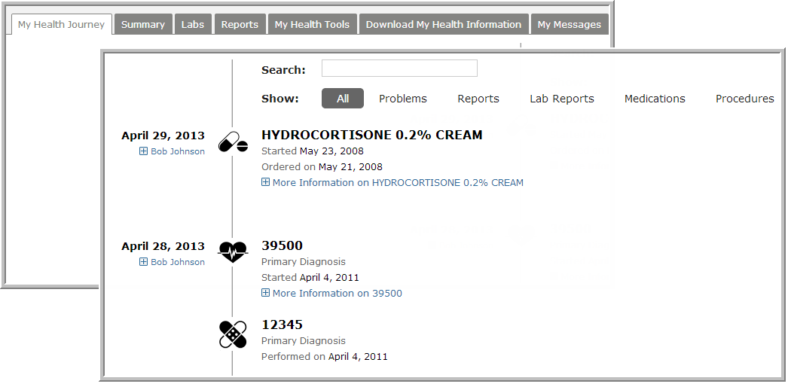

Use the Search box to filter the timeline by specific terms.

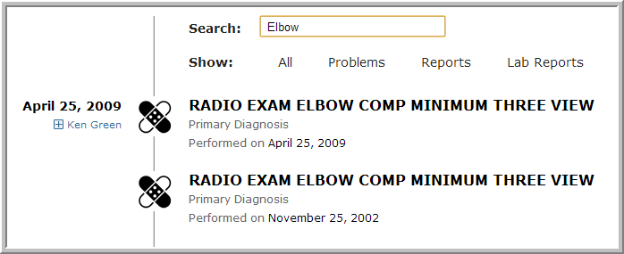

You can also filter the display by any of the types of information listed at the top, such as Problems.

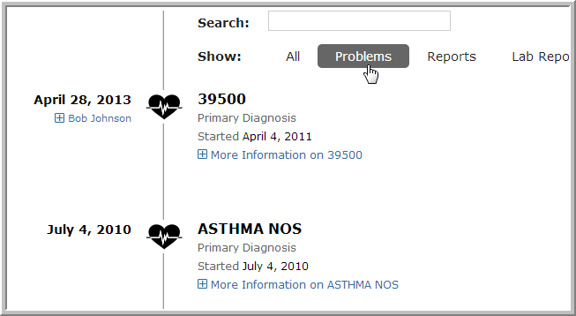

Click the **+**sign for more information about a healthcare provider or specific event in your timeilne.

